CRYPTO MUTUAL COIN (CCMC)

The purpose of cmc is to bring the concept of a mutual fund in main stream investments to the crypto economy. The concept of a mutual fund is a group of investors come together and mutually fund a company or companies providing a less riskier investment, by taking the risk of single company investments and spreading it out over multiple companies and investors. So not only does it advert risk but also works to further stabilize the economy on a whole. By creating a large fund that capitalizes on the growth of the market but is also slow moving in terms of turnover. We want CCMC to be a safe place for new persons entering the crypto space to learn, grow, and invest. As well as a place for seasoned traders and investors to store and generate wealth.

How does this translate to the crypto investment and how do we do this in a decentralized way that is the question we plan to answer and solve with CCMC.

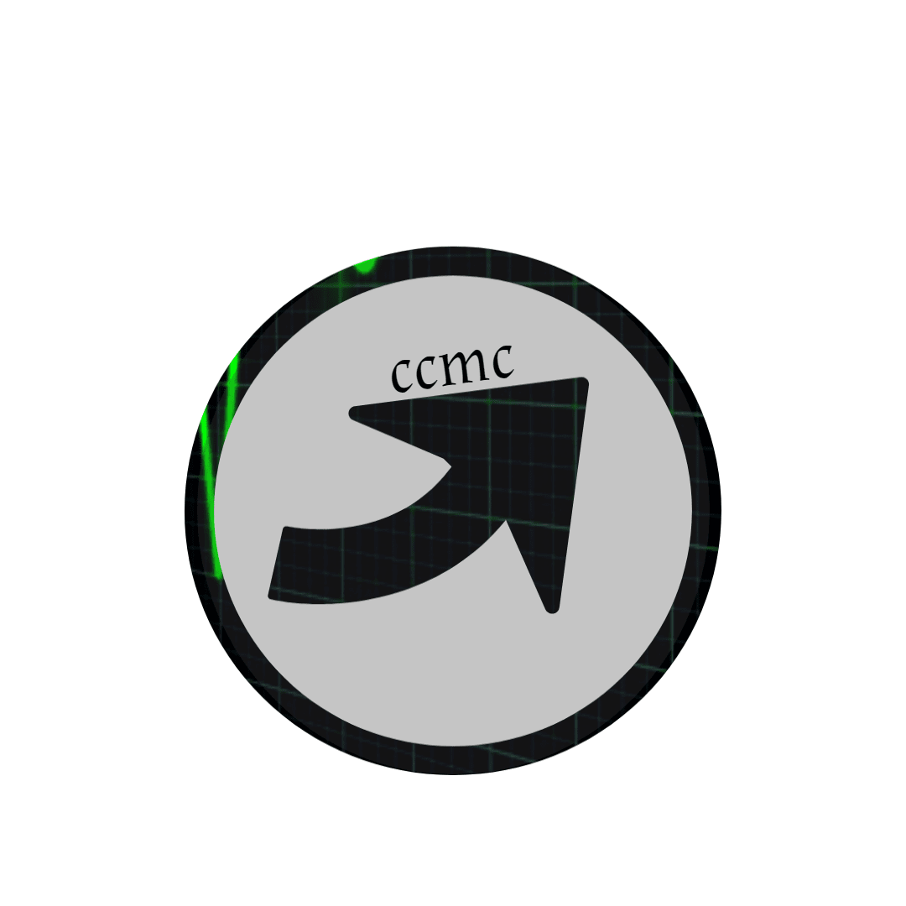

HOW IT WILL WORK

CCMC will capitalize on the growth of the market while minimizing the risk. By taking the risk of individual coin investing and spreading it around over multiple coins and investors and stabilizing the market through stabilized group funding. CCMC will also provide the buying power of thousands of investors putting there money into a single fund with one purpose and goal. Each CCMC token will directly represent the fund. Example: 1,000,000 CCMC in circulation and a total of $10,000,000 under management in the fund each token would then be worth $10 and as the fund grows so will each individual token in correlation. Because CCMC represents the fund it will not be subjectable to normal volatility after an ico .(Price doesn’t drop like a rock from investors dumping there holdings)

Which leads us to our next question how do we protect the fund (CCMC), and still allow liquidity to our investors. By putting the token out on normal exchanges and charging a fee for pulling invested money from CCMC fund. We encourage p2p trading allowing investors liquidity and discouraging by fee from pulling out of the fund. Like any investment the longer the money has to grow the larger it will grow. Also once the fund has reached maturity (all tokens have been sold) new investors will still be able to participate

TIME LINE

1stQRT 2017 coin concept

3rdQRT 2017 begin team build

4thQRT 2017 finish white paper and hold presale

1stQRT 2018 hold ICO

3rd QRT 2018 release wallet and open site

4ThQRT 2018 implement fund management program and release remaining CCMC/CMVT

DECENTRALIZED

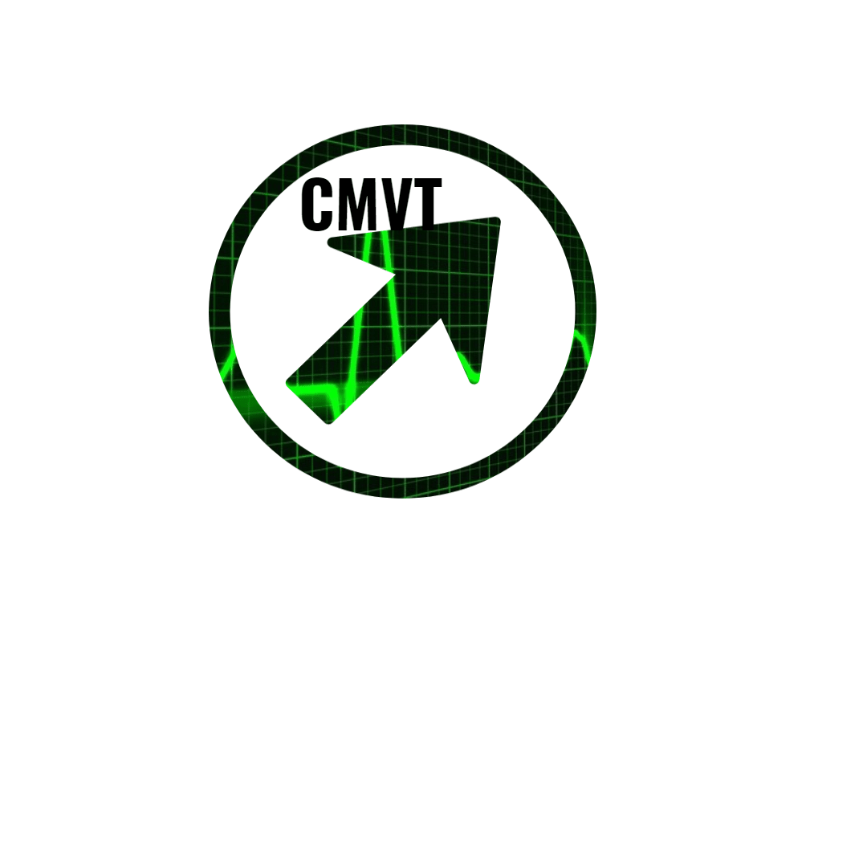It is the goal of Crypto Mutual Coin to become as decentralized as possible with this type of investment. So we will implement a vote token system (CMVT) for every 20 CCMC purchased from the fund you will be allotted 1 CMVT token. The tokens will be the keys to the fund management program, correlating site, and future exchange. As the fund reaches maturity more and more control of it will be given to the investors or group of investors until all of the CCMC and correlating CMVT have been sold excluding the small amount retained by our team for site maintenance and admin functions. It is the goal of CMC and our team not to control the fund but to provide one that will become self governed by investors unlike a normally structured mutual fund where a bank and a fund manager control everything and you give them your money to invest and trust that they will grow it. The direction of the fund its key values and infrastructure will be completely based off the CMVT token system and managed by the fund manager program. Example if the allocated funds are invested into 7 coins and 3 start to fail the fund management program will have the ability to liquidate the three invested coins and reallocate the funds to the remaining coins until the groups of investors can decide on how to proceed weather to start a new fund or add to the existing. Now not every investor will want to be active in the governing of the fund so by p2p exchanges of CMVT tokens we keep the system from having a large number of dead tokens. Investors can buy more control or sway of the fund through the purchase of CMVT p2p. This also gives the responsibility of not letting whales control the fund to the investors. Adding another level of value to cmc. (How much is your vote worth?)

Number of tokens (pre mined)

200,000,000 ccmc tokens

50% offered in ico to lay foundation of cmc fund

10% held for bounties

25% held in cold storage to be released after fund manager program is complete to insure healthy growth of fund and allow new investors to participate

15% held by the team

20,000,000 CMVT

20% offered in presale

25% to be joined with CCMC during ICO 20:1 ratio

10% held for bounties

25% held in cold storage till completion of fund management program to be released with second half of CCMC

20% held by the team to preform admin duties

We will hold a pre sale of cmvt for funding. The start up funds raised will be used to finish team build, upgrade hardware and also to pay for advertisement of the upcoming Ico.

Presale will have a max supply of 4,000,000 CMVT and a funding goal of 500 ETH at

350 ETH= 1 CMVT

Persons participating in the presale will have the advantage of holding a larger number of cmvt at a lower price point than persons only participating in the Ico. Giving early investors more control over the fund.

FRAME WORK AND DELEGATE SYSTEM

The goal of our team is not to own a mutual fund or profit from it but to build the framework for a cryptocurrency decentralized fund. The frame work will consist of a site with individual wallets resembling an exchange. An internal market for p2p trading of CMVT and CCMC. Within the site and its ecosystem will be the fund which will be run by the fund management program. A Bot which will be in charge of overseeing the fund and performing all actions within the fund this bot will have pre determined permissions that it will operate within. The reason for using a bot or computer program is a program cannot lie cheat or steal it is neither moral or immoral but only does what it is programed to do. Ours will be programed to maintain the fund and will have the permission to liquidate small amounts of the fund incase of a failing investment but with a limit. Other than these permissions It will be controlled by CMVT. To protect the fund management program and the fund itself there will be a predetermined percentage of the over all CMVT to change anything (70 percent agreement).

We will use a sort of proof of stake within the site for investors that will represent the amount of CMVT they are in possession of. This proof of stake will give each individual a rank representing there vote or control over the fund. They will be able to use this rank to vote on delegates or if they are in control of a large percentage of cmvt will become a delegate themselves. Note: CMVT coins will not be spent in this scenario or burnt we do this because over time within the interaction with the site and the limited amount of CMVT the site would end up with all CMVT and control the fund, or there would be not more CMVT.

Lets say that within the fund there are 5 major types of investors. One group believes the funds should be vested in large cap coins like btc eth. Another group believes the funds should be used for start ups and Ico’s so on and so on. Each group will then be able to vote on a delegate to speak for there cmvt. In a way loaning there CMVT and its power to this delegate who will then compete and convers with the other delegates and team on fund allocation. Maybe they decide a portion should go to large cap and another portion of the fund will be set aside to invest in start ups . It will be up to the delegates and the holders of cmvt to decide on allocation. The delegation system will not be the only use for cmvt on the site. After the Ico and before the site is built the funds from the sale of ccmc will be invested in large cap coins and growth coins. Meaning it will be invested in btc eth ltc these are large cap and also a few growth coins such as neo ark omg. The team will decide the allocation before the start of Ico based on current market and early investor feed back.

ADVISORS

During presale we will offer 10 advisor positions. These positions will be offered to early contributors of 10 ETH or more.

The advisors will act as a sort of board overseeing and consulting on business decisions and initial fund allocation please contact Kenneth McDonald our founder for more information kenneth@cryptomc.com